Clemson Senior Design

  - LoRa Radio Evaluation Designs Software Requirements

AE304194-001
Revision: -
27 January 2025

Prepared For:

Riggs Hall,
Clemson, SC 29634

Prepared By:
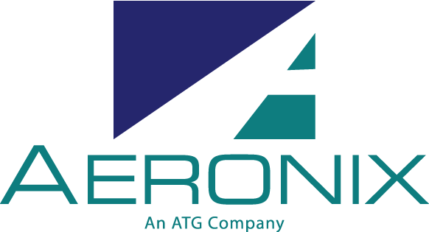
1775 West Hibiscus Blvd., Suite 200
Melbourne FL 32901
(321) 984-1671

Documentation Authorization
Review/Approval | Title Name
Originator: | D. Kaisner
Approved By:  Engineering | D. Kaisner
Approved By:  Quality Assurance | D. Cottee
Approved By:  Configuration Management | D. Franks
Approved By:  Project Manager | T. Jandreau

Document Revision History

Rev | Description of Change | Changed By | Chg/Rel# | Date
L3/- | Initial Release | D. Kaisner |  | 1/27/2025

Table of Contents
1. SCOPE 1
2. Design Specifications 1
2.1. General Requirements (Primary) 1
2.1.1. Standards and Best Practices 1
2.1.2. Shared messaging protocol 1
2.1.3. Reliable Communication 1
2.1.4. Radio Band 2
2.1.5. Endpoint Capacity 2
2.1.6. Serial Debug 2
2.1.7. SWaP 2
2.2. LoRa Mesh (Car Radio) 3
2.2.1. LoRa Chipset (Primary) 3
2.2.2. Processor Selection (Primary) 3
2.2.3. Command Message Protocol (Primary) 3
2.2.4. Low Power (Primary) 3
2.2.5. GPIO Braking (Primary) 3
2.2.6. Wake-From-Low_Power (Secondary) 3
2.3. IP Backhaul (Base Station) 3
2.3.1. LoRa Chipset (Primary) 3
2.3.2. Processor (Primary) 4
2.3.3. Command Message Protocol (Primary) 4
2.3.4. Web Interface (Primary) 4
2.3.5. Spectrum Scan (Secondary) 4

Table of Figures
Figure 1: Train Length Distribution Over Time 2

SCOPE
This documentation outlines the software specifications and priorities for the design work done by the Clemson Senior design team in creating the LoRa Radio Hub Evaluation Board and the LoRa Radio Traincar Evaluation Board.

The purpose of these designs is to facilitate research into how LoRa radios can be used to create mesh networks for utilization on trains for various signaling and data monitoring applications.

Design Specifications
The requirements for the software have been broken down into general requirements and project-specific requirements. Each requirement has an appropriate priority assigned.
Priorities are separated into primary and secondary. The goal should be to complete all the primary subsystems before work starts on secondary subsystems.

General Requirements (Primary)

Standards and Best Practices
(AER-LORA-SW1) Follow Aeronix standards and best practices for software development

Git Repository
(AER-LORA-SW2) Software shall be kept in a repository following git best practices (i.e. Pull Requests, branching, etc)

Coding Standard
(AER-LORA-SW3) Written software shall conform to a consistent coding standard (either Aeronix coding standard or other published standard)

Shared messaging protocol
(AER-LORA-SW4) Both software components should have a shared messaging protocol. There should be commands to accommodate variable braking, setting the RF channel, and getting status information from a node. Status information can include the RF channel, network information, braking info, etc.

Reliable Communication
(AER-LORA-SW5) Mesh radio shall be able to send communications reliably from HoT to EoT.
- Trains can be 14,000 ft in length at a maximum: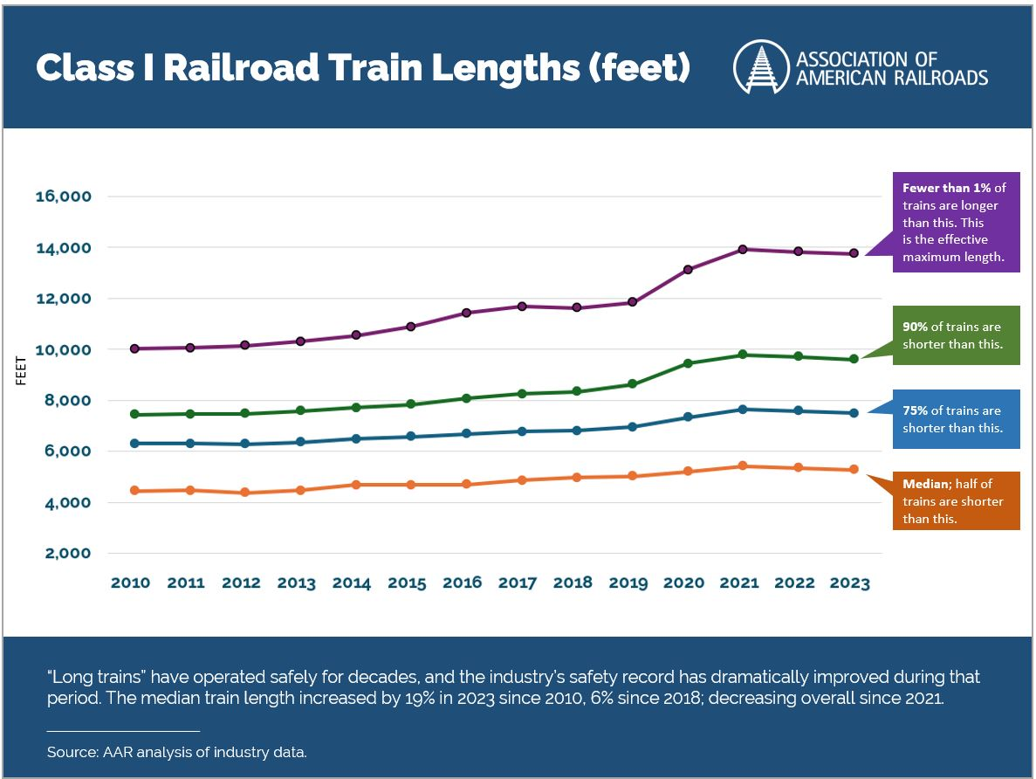
Figure 1: Train Length Distribution Over Time

- Antenna selection and radio placement on the train cars will factor into communication lengths. Assume those will be average optimal.

Radio Band
(AER-LORA-SW6) Radios shall communicate in the US unlicensed radio band for LoRa (902.0 - 928.0 MHz)

Endpoint Capacity
(AER-LORA-SW7) Mesh network shall have the ability to support up to 200 endpoints on a single train network, with a minimum of 2 base stations (locomotives)
- Candidate network stack is Meshtastic.
- Other network stacks are acceptable given appropriate trade study.

Serial Debug
(AER-LORA-SW8) Devices shall implement a serial debug interface.

SWaP
(AER-LORA-SW9) Devices should optimize SWaP (Size, Weight, and Power).

LoRa Mesh (Car Radio)
The overall goal of the Car Radio is to listen for commands from the base stations and respond accordingly. The car radios will form a mesh network to ensure communication across all cars in the train.

LoRa Chipset (Primary)
(AER-LORA-SW10) The LoRa radio shall use the SX1276 chipset. The SX1250 front end module is not required but is recommended.

Processor Selection (Primary)
(AER-LORA-SW11) The MCU shall be in the STM32L4 low-power family.

Command Message Protocol (Primary)
(AER-LORA-SW12) Work with the IP Backhaul team (Section 2.3) to agree on a command message protocol.

Low Power (Primary)
(AER-LORA-SW13) Implement mesh networking on processor with a path towards low-power design.

GPIO Braking (Primary)
(AER-LORA-SW14) Provide a GPIO output that can set braking percentage from 0 – 100% based on received commands over the mesh network.

Command Line Interface (Primary)
(AER-LORA-SW15) The devices should provide a Command Line Interface over debug serial which provides the following commands and functionality:
Command | Function
help | Display help text
gps.status | Get current GPS status
imu.status | Get current IMU status
spi.read <dev> <bytes> | Read <bytes> from spi <device>
bit | Run full Built-in-Test
bit.lora | Run a Built-in-Test of the LoRa device
bit.gps | Run a Built-in-Test of the GPS device
bit.imu | Run a Built-in-Test of the IMU device
bit.i2c | Run a Built-in-Test of the I2C bus

Wake-From-Low_Power (Secondary)
(AER-LORA-SW16) Implement wake-from-low-power based on IMU input.

IP Backhaul (Base Station)
The overall goal of the Base Station is to process commands from a web interface and forward those commands to all the Car Radios. The web interface software should allow the user to send commands to connected nodes and view the status of all nodes connected to the IP backhaul. The Base Station should be connected to the web interface via Ethernet (hence IP backhaul). The Base Station software should run on students' choice of an embedded Linux distribution and is responsible for forwarding commands from the web interface to the Car Radios, and forwarding responses back to the web interface. If time allows, the base station should implement spectrum scanning where the base station finds an acceptable RF channel and sets all nodes accordingly.
The local processor for the Traincar design shall be from the STM32L4 series of chips. These allow drastically reduced power needs in exchange for much lighter performance.

LoRa Chipset (Primary)
(AER-LORA-SW17) The LoRa radio shall use the SX1276 chipset.

Processor (Primary)
(AER-LORA-SW18) The local processor for the Hub design will be the ATSAMA5D27-D1G. This unit is a System-in-Package that incorporates some of the more complex layout issues, like DDR memory routing, onto a single chip. This gets us the performance we need without overcomplicating the evaluation design.

Command Message Protocol (Primary)
(AER-LORA-SW19) Work with the LoRa Radio team to agree on a command message protocol.

Web Interface (Primary)
(AER-LORA-SW20) Design a web interface that can send command messages to the Base Station, which forwards them to the Car Radios. The web interface should be able to display status information about the connected nodes.

Spectrum Scan (Secondary)
(AER-LORA-SW21) Implement a spectrum scan command that searches for an unused RF channel and uses that channel for communication.

